Test Case: tc002_SPX_Dev5_Crear_Requisicion_Spot_Tipo_Cobro_Project
Step 1 - Enter username and password and click to button Enter: Credentials Entered
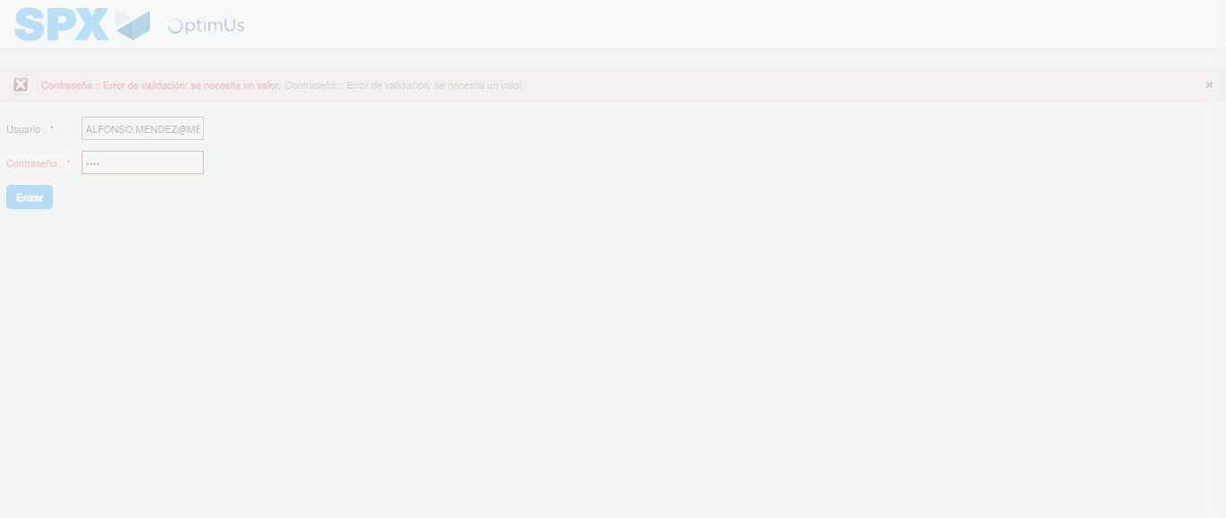Image file-name: QC_Testing-tc002_SPX_Dev5_Crear_Requisicion_Spot_Tipo_Cobro_Project-1783378332161

Step 2 - Select to UEN and Access to Spot Buy Requisitions : UEN Correctly selected and Correct access
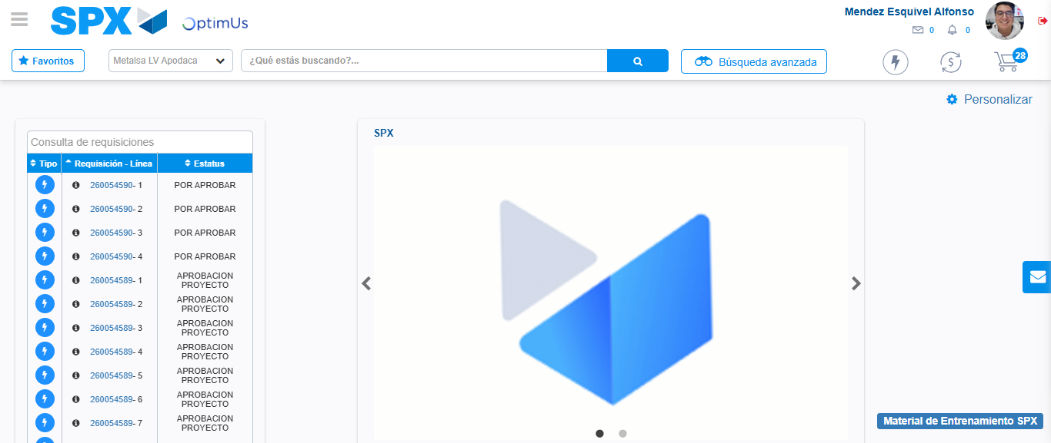Image file-name: QC_Testing-tc002_SPX_Dev5_Crear_Requisicion_Spot_Tipo_Cobro_Project-1783378357820

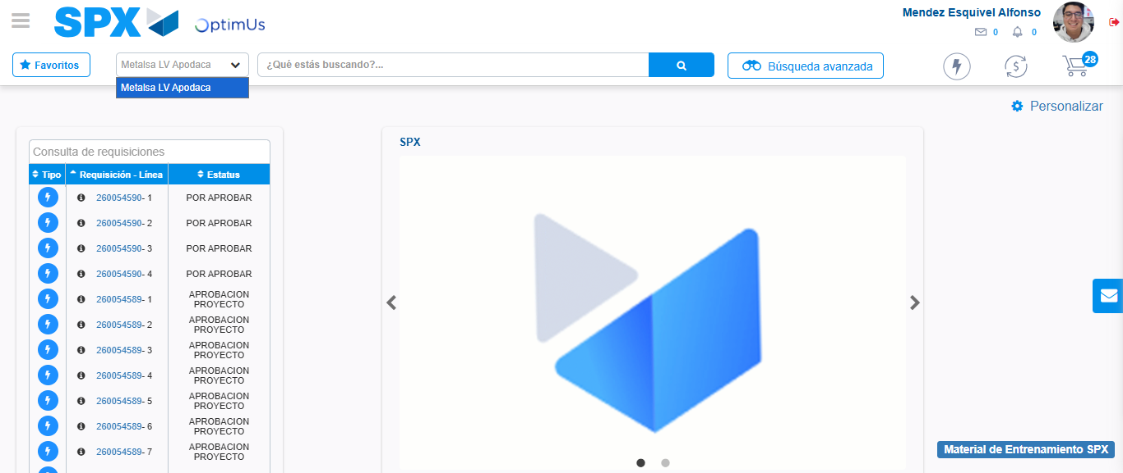Image file-name: QC_Testing-tc002_SPX_Dev5_Crear_Requisicion_Spot_Tipo_Cobro_Project-1783378360332

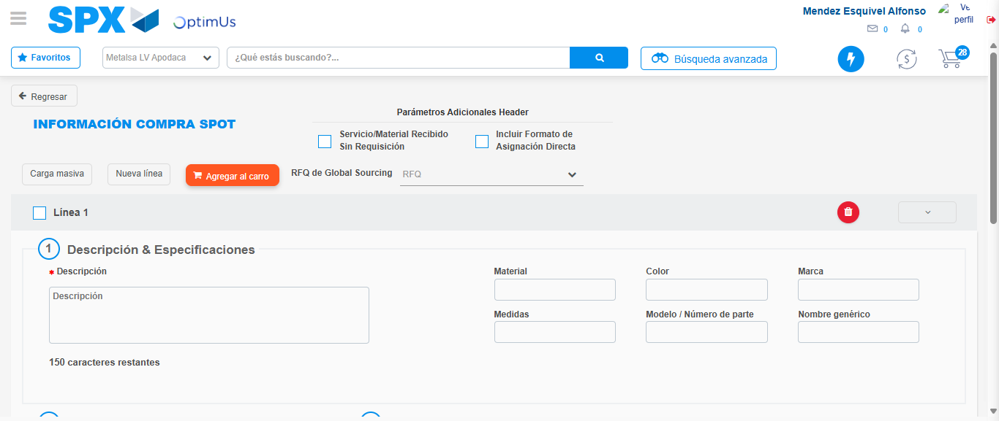Image file-name: QC_Testing-tc002_SPX_Dev5_Crear_Requisicion_Spot_Tipo_Cobro_Project-1783378379641

Step 3 - Data Capture Spot Buy Requisition: Data captured correctly
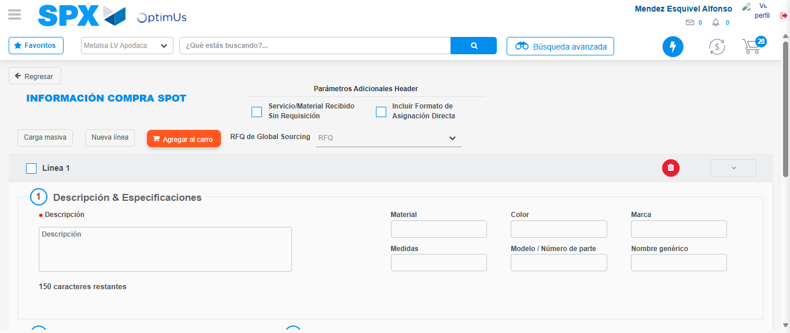Image file-name: QC_Testing-tc002_SPX_Dev5_Crear_Requisicion_Spot_Tipo_Cobro_Project-1783378379930

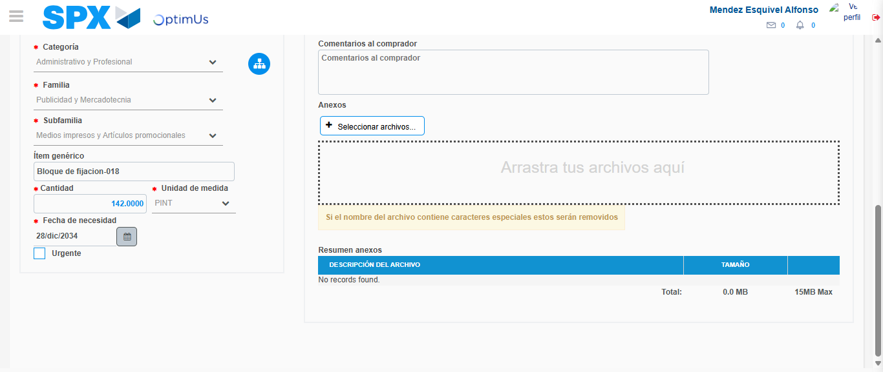Image file-name: QC_Testing-tc002_SPX_Dev5_Crear_Requisicion_Spot_Tipo_Cobro_Project-1783378390002

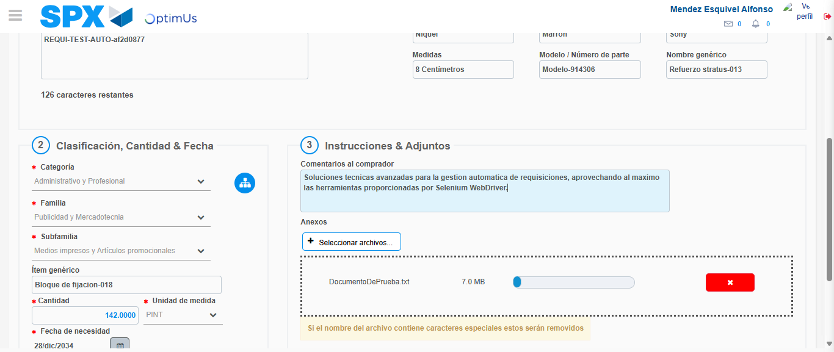Image file-name: QC_Testing-tc002_SPX_Dev5_Crear_Requisicion_Spot_Tipo_Cobro_Project-1783378390806

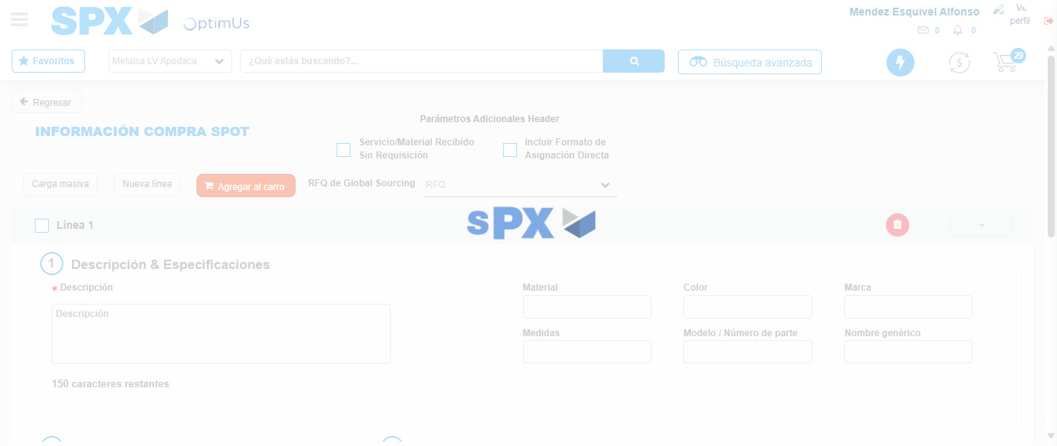Image file-name: QC_Testing-tc002_SPX_Dev5_Crear_Requisicion_Spot_Tipo_Cobro_Project-1783378397132

Step 7 - Return to Main Page SPX : Return to Main Page SPX
Image file-name: QC_Testing-tc002_SPX_Dev5_Crear_Requisicion_Spot_Tipo_Cobro_Project-1783378357820

Image file-name: QC_Testing-tc002_SPX_Dev5_Crear_Requisicion_Spot_Tipo_Cobro_Project-1783378360332

Image file-name: QC_Testing-tc002_SPX_Dev5_Crear_Requisicion_Spot_Tipo_Cobro_Project-1783378379641

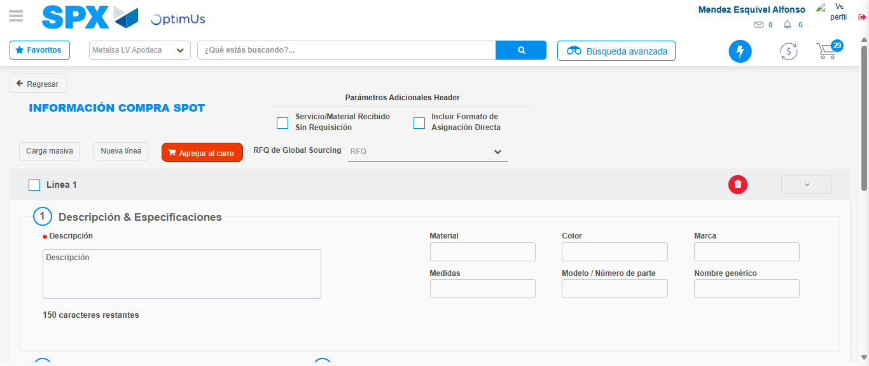Image file-name: QC_Testing-tc002_SPX_Dev5_Crear_Requisicion_Spot_Tipo_Cobro_Project-1783378399481

Image file-name: QC_Testing-tc002_SPX_Dev5_Crear_Requisicion_Spot_Tipo_Cobro_Project-1783378399759

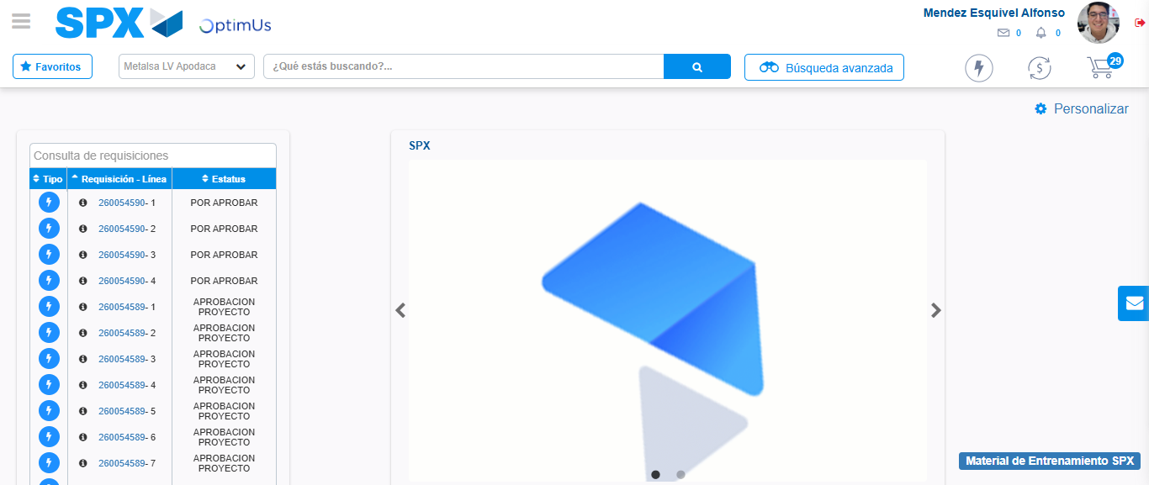Image file-name: QC_Testing-tc002_SPX_Dev5_Crear_Requisicion_Spot_Tipo_Cobro_Project-1783378420804

Step 8 - Log Out : Log Out SPX
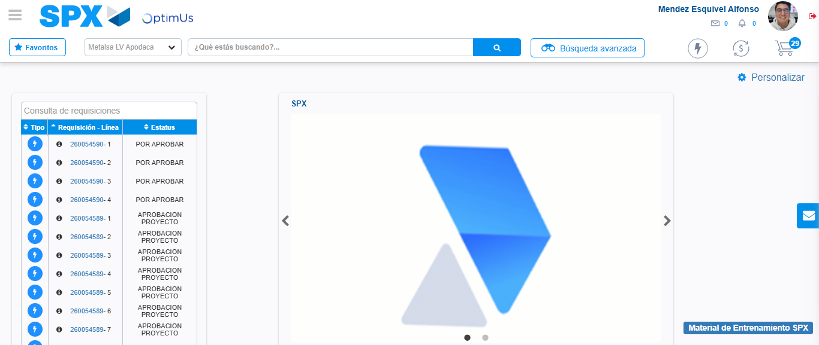Image file-name: QC_Testing-tc002_SPX_Dev5_Crear_Requisicion_Spot_Tipo_Cobro_Project-1783378421024

